**EXPERIMENT-10**

**DATE: 29-09-2025**

**AIM:**

To create a cloning of a vm and test it by loading the previous version/cloned vm.

**PROCEDURE:**

**STEP 1**: GO TO VM AND GOTO MANAGE AND CLICK CLONE

**STEP 2:** CLICK CLONE

**STEP 3:** SELECT THE FULL CLONE

**STEP 4**: AFTER CLONE AGAIN OR VM IS OPENED.

**IMPLEMENTATION:**

**CLONING OF A VM**

**STEP 1: GO TO VM AND GOTO MANAGE AND CLICK CLONE**

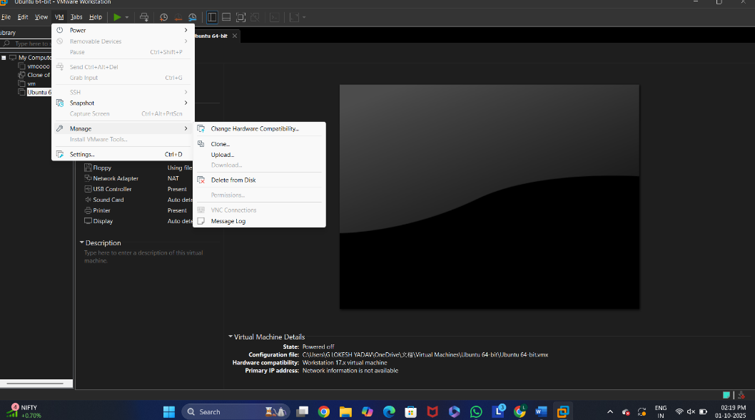

**STEP 2: CLICK CLONE**

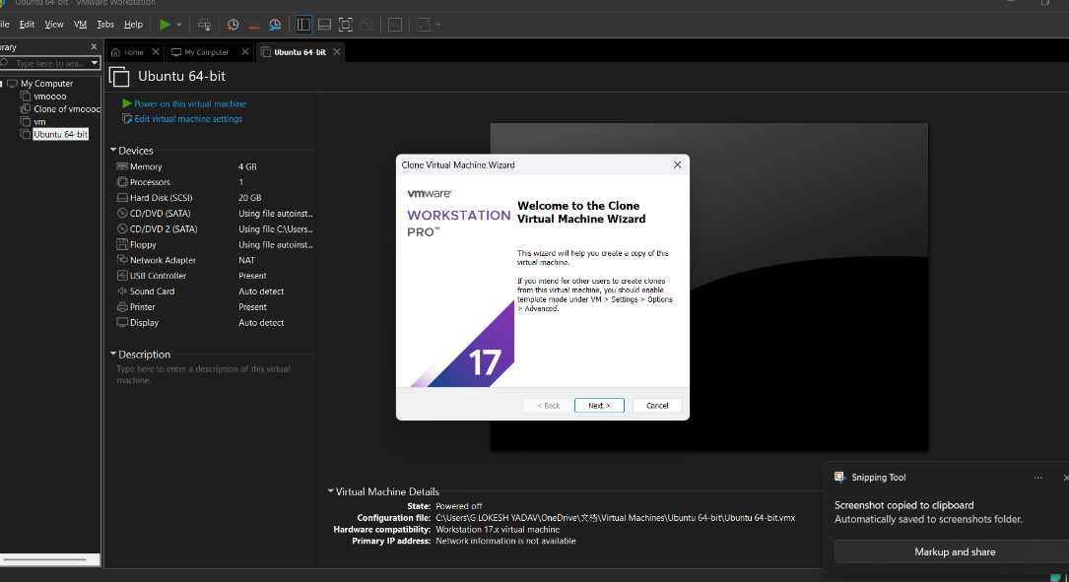

**STEP 3: SELECT THE FULL CLONE**

**STEP 4: AFTER CLONE AGAIN OR VM IS OPENED.**

**RESULTS;** successfully created a cloning of a vm and test it by loading the previous version/cloned vm.